**REPORT**

Zajęcia: Analog and digital electronic circuits

Teacher: prof. dr hab. Vasyl Martsenyuk

**Lab 13**

24.04.2025

**Topic:** "ECG Signal Processing: Filtering, R-peak Detection, and Heart Rate Analysis"

**Variant: 13**

Rafał Żmuda

Informatyka II stopień,

stacjonarne,

1 semestr,

Gr.2b

1. **Problem statement:**

* Preprocess a simulated or real ECG signal.
* Apply bandpass filtering to remove baseline drift and high-frequency noise.
* Detect R-peaks in the filtered signal.
* Calculate and plot heart rate over time.
* Interpret the results based on signal quality and parameter choices.

**2. Input data:**

Duration: 12 s, Sampling Rate: 500 Hz, Filter: 0.5–50 Hz

**3. Commands used (or GUI):**

Creating input signal and applying filters

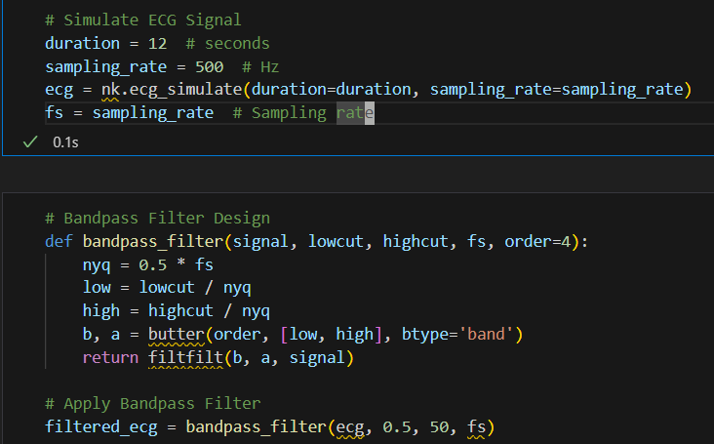

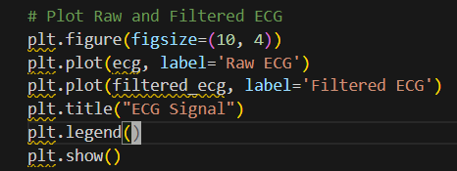

Output:

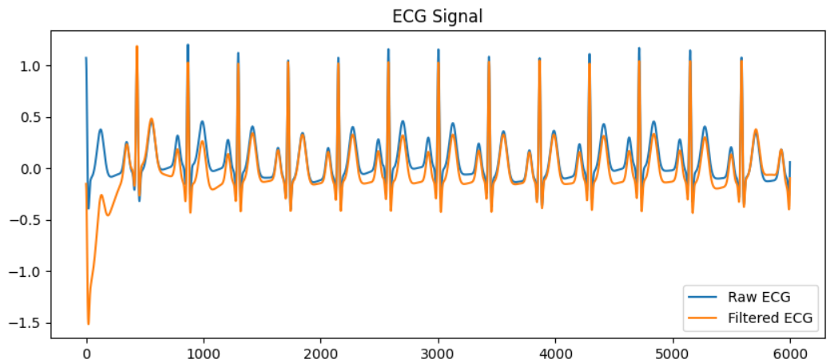

R-peak detection and ploting

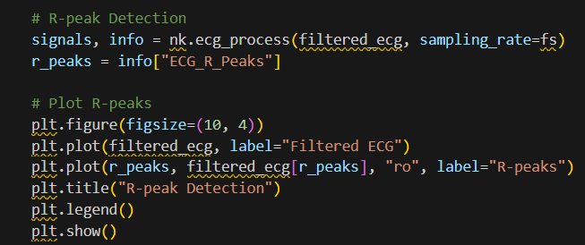

Output:

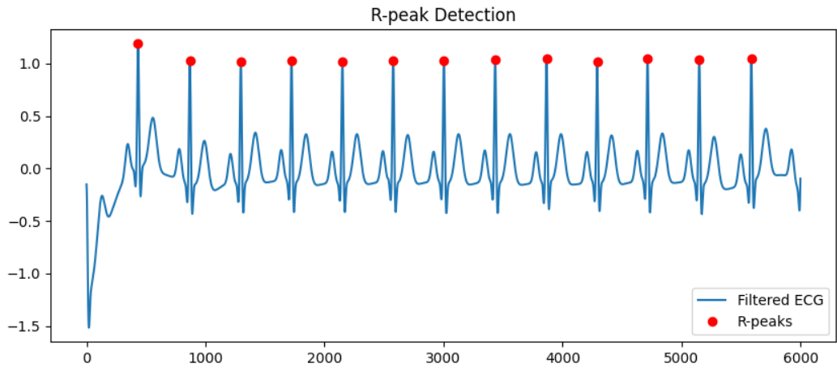

Heartrate calculation and ploting

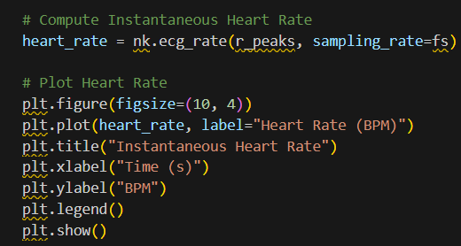

Output:

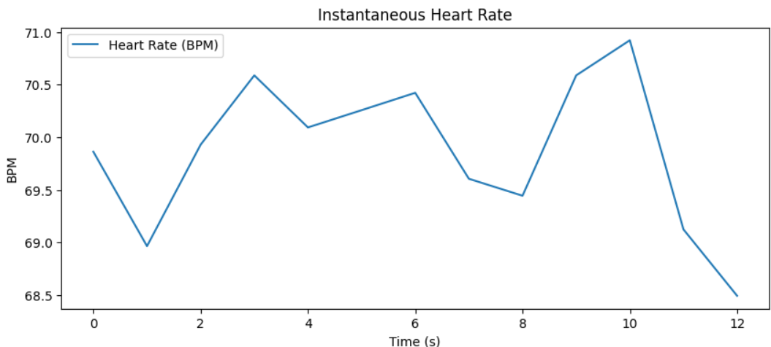

Link to remote repository: https://github.com/RafalZmu/School/tree/main/Lab%2013

**5. Conclusions:**

This task demonstrates the application of digital signal processing techniques to analyze ECG signals. By simulating an ECG signal, applying a bandpass filter, and detecting R-peaks, we observe how filtering enhances signal clarity and improves the accuracy of R-peak detection. The computation of instantaneous heart rate further highlights the practical use of these techniques in biomedical signal analysis. Overall, this workflow showcases the importance of preprocessing and feature extraction in ECG analysis, which is critical for applications like heart rate monitoring and arrhythmia detection.